
BIT4138: Advanced Cryptography

Student Details
Student Name: Kevin Mburu Gitau

Admission Number: BSCCS/2024/58901

Course/Class: Bachelors of Science in Computer Science/2024

Unit Code: BIT4138

Unit Name: Advanced Cryptography

Lecturer Name: Michael Nyoro

Semester/Academic Year: 3.2

Project Details
Project Title:
Selected Technologies:

Project Details

Project Title
Examples:
- Secure File Encryption System
- Password Hashing and Authentication System
- RSA Secure Messaging Platform
- AES File Protection Tool
- Secure Login and Digital Signature System

Selected Technologies
Examples:
- Python
- Python + Cryptography Library
- OpenSSL + Linux
- Kali Linux Security Tools
- Wireshark + Python

Online Portfolio / GitHub Link
https://github.com/kevinmburugitau/advanced_cryptographyt

Table of Contents
Student Details 1
Project Details 1
Project Details 2
Project Title 2
Selected Technologies 2
Online Portfolio / GitHub Link 2
Week 1: Cryptography Environment Setup 7
Title 7
Fig 1: Installation of Python and VS Code 7
Fig 2: Installation of Cryptography Libraries 7
Fig 3: OpenSSL Installation Test 8
Fig 4: Local Encryption Script Execution 8
Fig 5: GitHub Repository Initialization 8
Student Reflection 9
Week 2: Classical Cryptography and Cipher Design 10
Title 10
Fig 1: Caesar Cipher Implementation 10
Fig 2: Vigenère Cipher Encryption Process 11
Fig 3: User Input Validation Interface 11
Student Reflection 12
Week 3: Stream Ciphers and Randomness Testing 13
Title 13
Fig 1: LFSR Generator Implementation 14
Fig 2: Pseudorandom Sequence Output 14
Fig 3: Statistical Randomness Testing 15
Fig 4: RC4 Stream Cipher Simulation 15
Fig 5: Encryption Performance Results 16
Student Reflection 16
Week 4: Block Cipher Design and AES 17
Title 17
Fig 1: AES Encryption Script 17
Fig 2: Key Generation Process 17
Fig 3: File Encryption Demonstration 18
Fig 4: Decryption Results 18
Fig 5: AES Performance Testing 18
Student Reflection 18
Week 5: Public Key Cryptography (RSA) 19
Title 19
Required Evidence 19
Fig 1: RSA Key Pair Generation 19
Fig 2: Public Key Encryption Process 20
Fig 3: Private Key Decryption Results 20
Fig 4: Secure Message Transmission 21
Fig 5: RSA Testing and Validation 21
Student Reflection 21
Week 6: Hashing and Password Security 23
Title 23
Required Evidence 23
Fig 1: SHA-256 Hash Generation 23
Fig 2: Password Hashing System 23
Fig 3: Login Authentication Workflow 23
Fig 4: Hash Verification Results 23
Fig 5: Password Security Testing 23
Student Reflection (Maximum 50 Words) 23
Example 23
Week 7: Digital Signatures and Certificates 23
Title 23
Required Evidence 24
Fig 1: Digital Signature Generation 24
Fig 2: Signature Verification Process 24
Fig 3: Certificate Creation Using OpenSSL 24
Fig 4: Secure Document Validation 24
Fig 5: Certificate Testing Results 24
Student Reflection (Maximum 50 Words) 24
Example 24
Week 8: Secure Communication Protocols 24
Title 24
Required Evidence 24
Fig 1: SSL/TLS Configuration 24
Fig 2: Secure HTTPS Communication Test 24
Fig 3: Wireshark Traffic Capture 25
Fig 4: Encrypted Data Transmission 25
Fig 5: Protocol Security Analysis 25
Student Reflection (Maximum 50 Words) 25
Example 25
Week 9: Cryptanalysis and Security Testing 25
Title 25
Required Evidence 25
Fig 1: Brute Force Attack Simulation 25
Fig 2: Password Cracking Demonstration 25
Fig 3: Weak Key Analysis 25
Fig 4: Cryptanalysis Workflow 25
Fig 5: Security Recommendations Report 25
Student Reflection (Maximum 50 Words) 26
Example 26
Week 10: Final System Integration and Deployment 26
Title 26
Required Evidence 26
Fig 1: Complete System Dashboard 26
Fig 2: Integrated Encryption Workflow 26
Fig 3: User Authentication Module 26
Fig 4: Final Testing Results 26
Fig 5: GitHub Final Repository Update 26
Student Reflection (Maximum 50 Words) 26
Example 27
Key Instructions to Students 27
Focus on Security Workflow and System Progress 27
Important Academic Requirements 27
Example: 28
Recommended Tools for Students 28
Lecturer Observation Focus 28
Industry-Oriented Reminder to Students 28

Week 1: Cryptography Environment Setup

Title
Installation and Configuration of Cryptography Development Environment
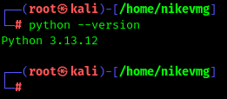

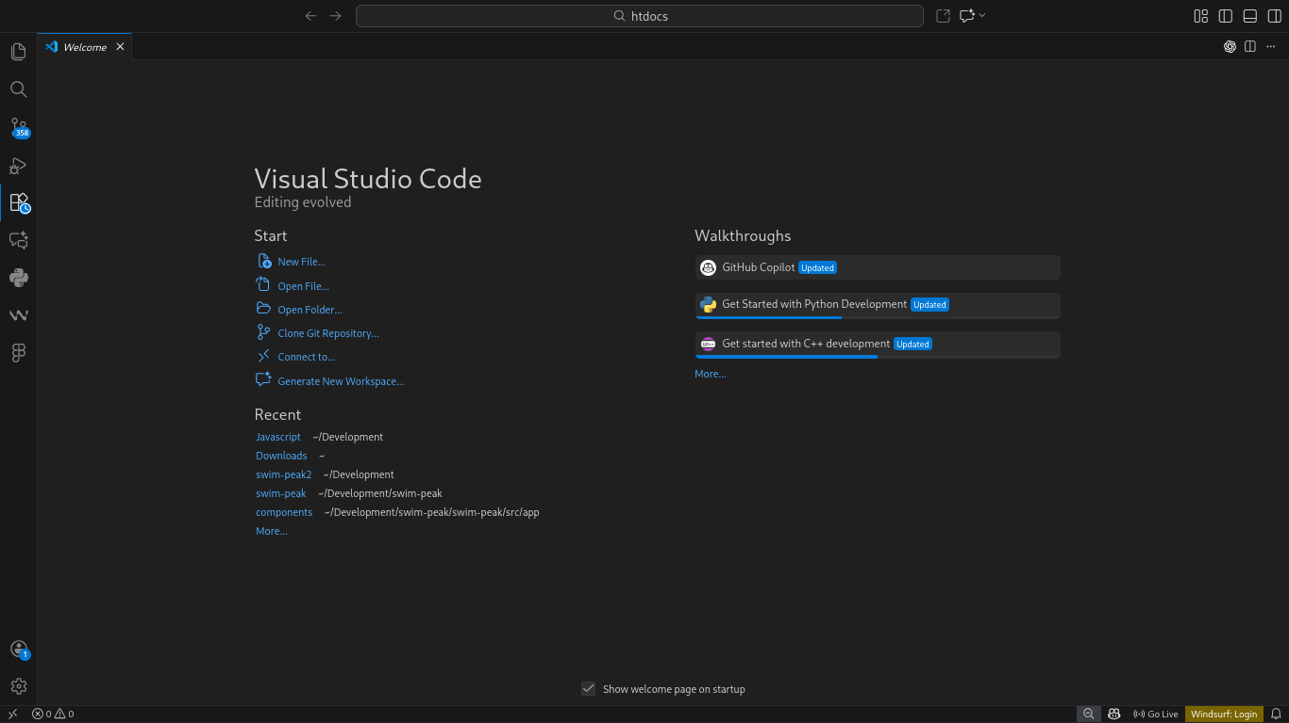
Fig 1: Installation of Python and VS Code
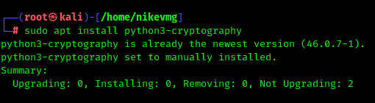

Fig 2: Installation of Cryptography Libraries

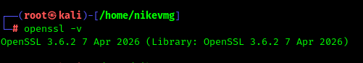

Fig 3: OpenSSL Installation Test
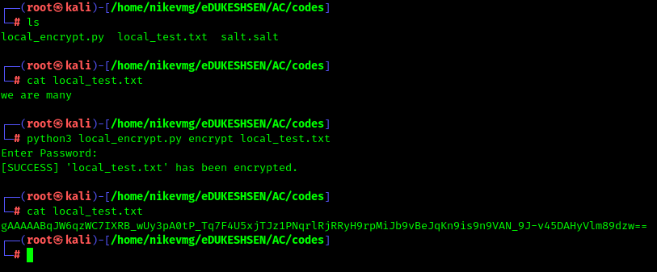

Fig 4: Local Encryption Script Execution
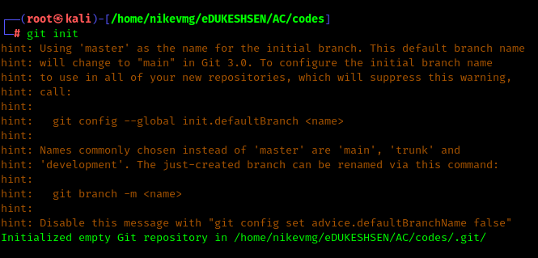

Fig 5: GitHub Repository Initialization

Student Reflection
Setting up Python, VS Code, and OpenSSL took longer than expected due to PATH configuration errors. Once resolved, running my first encryption script was satisfying. I now understand why a proper development environment matters before writing any cryptographic code. GitHub setup also helped me appreciate version control early.

Week 2: Classical Cryptography and Cipher Design

Title
Implementation of Classical Encryption Algorithms

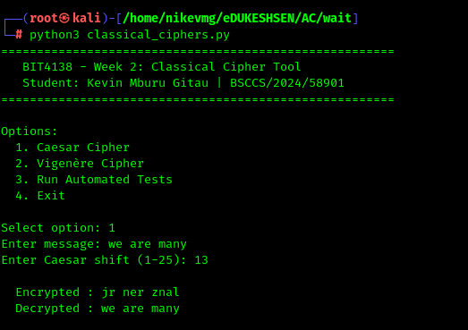

Fig 1: Caesar Cipher Implementation
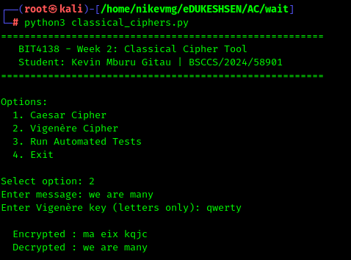

Fig 2: Vigenère Cipher Encryption Process
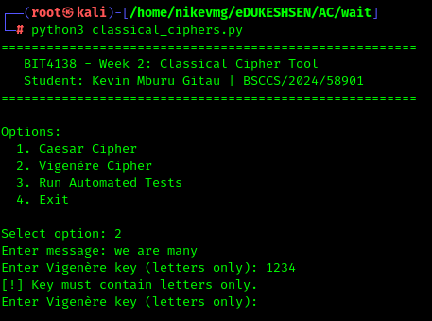

Fig 3: User Input Validation Interface

Student Reflection
Implementing Caesar and Vigenère ciphers showed me how simple substitution is to break. The key length in Vigenère makes a real difference in security. Writing the validation tests myself helped me understand why modern encryption moved far beyond these classical methods.

Week 3: Stream Ciphers and Randomness Testing

Title
Implementation of Stream Cipher Systems and Random Sequence Analysis

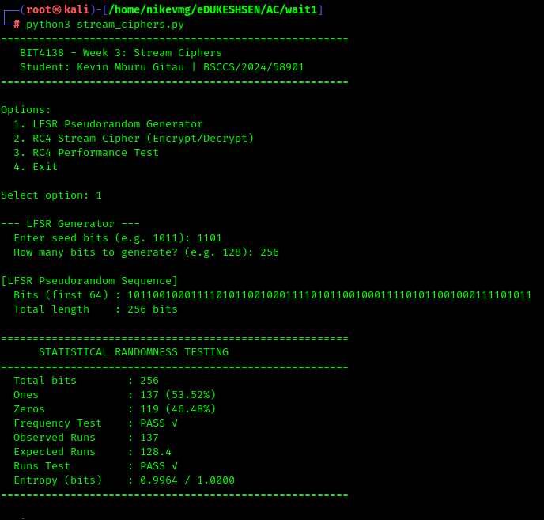
Fig 1: LFSR Generator Implementation
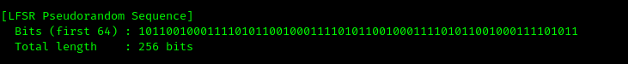

Fig 2: Pseudorandom Sequence Output
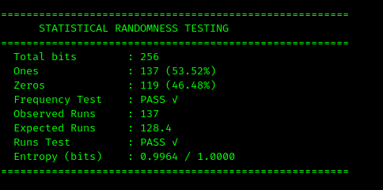

Fig 3: Statistical Randomness Testing
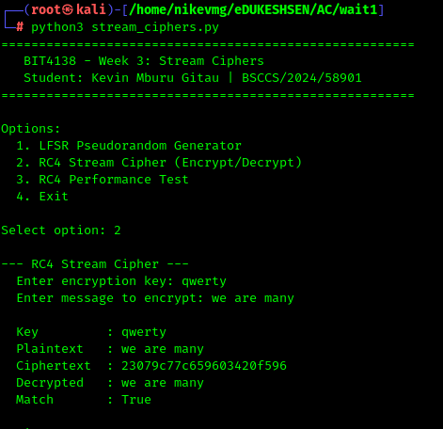

Fig 4: RC4 Stream Cipher Simulation
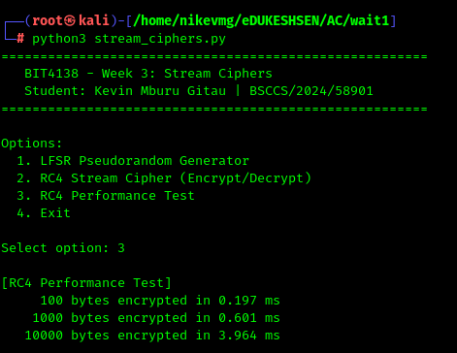

Fig 5: Encryption Performance Results

Student Reflection
Building an LFSR from scratch clarified how pseudorandomness works in cryptography. The statistical tests surprised me — even simple sequences can pass randomness checks. RC4 was interesting to implement but I learned it's now considered insecure, which reinforced why algorithm choice matters in real systems.

Week 4: Block Cipher Design and AES

Title
Advanced Encryption Standard (AES) and Block Cipher Operations

Fig 1: AES Encryption Script

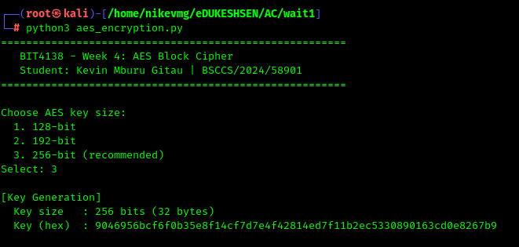
Fig 2: Key Generation Process

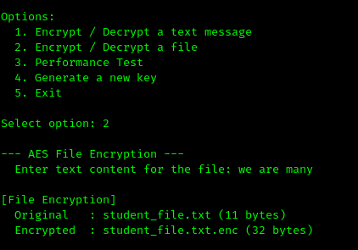

Fig 3: File Encryption Demonstration
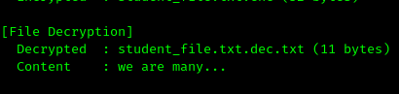

Fig 4: Decryption Results
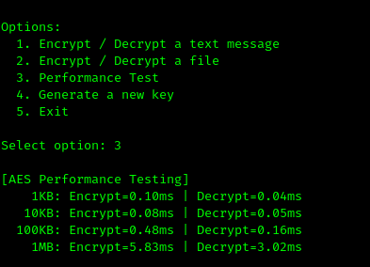

Fig 5: AES Performance Testing

Student Reflection
AES felt more complex than the earlier ciphers, especially understanding padding and IV usage. Encrypting an actual file and seeing the binary output made it feel real. The performance test showing 1MB encrypted in under 3ms helped me appreciate why AES is the industry standard.

Week 5: Public Key Cryptography (RSA)

Title
Implementation of RSA Encryption and Key Management

Required Evidence
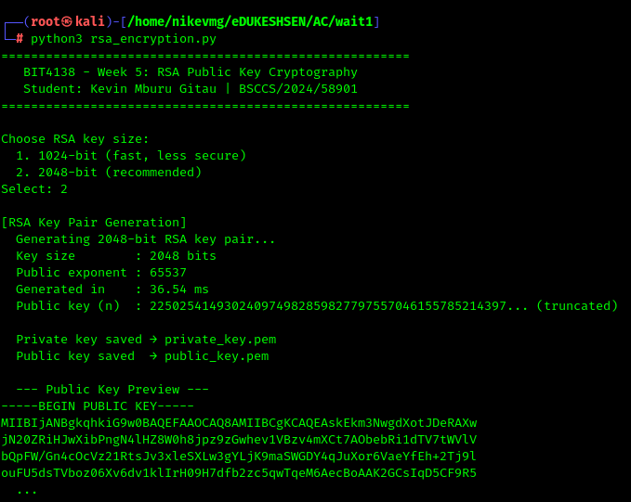

Fig 1: RSA Key Pair Generation
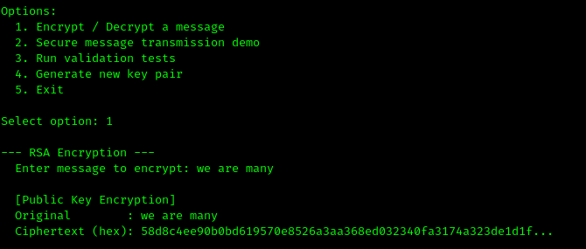

Fig 2: Public Key Encryption Process
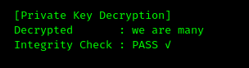

Fig 3: Private Key Decryption Results
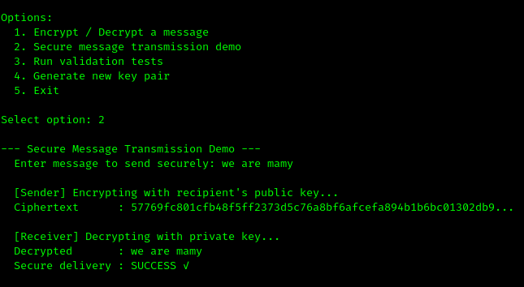

Fig 4: Secure Message Transmission
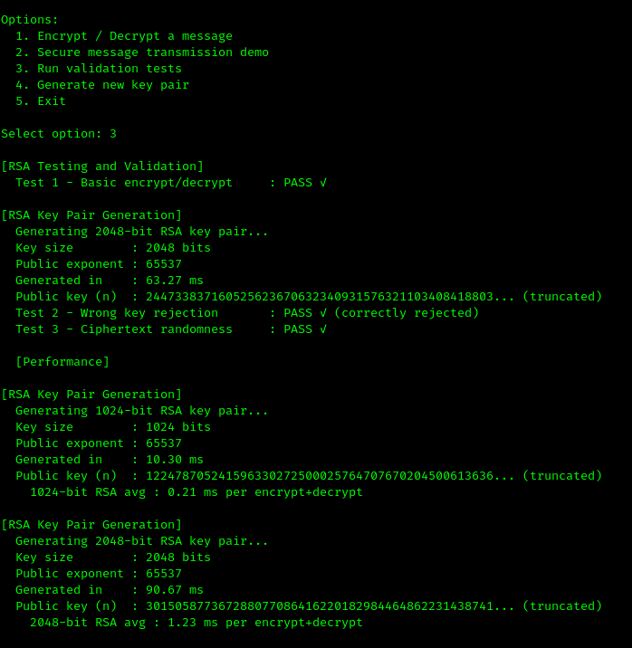

Fig 5: RSA Testing and Validation

Student Reflection
RSA shifted my thinking from shared secrets to public/private key pairs. Watching the wrong-key rejection test fail correctly was the most valuable moment — it showed the math actually holds. The performance gap between 1024-bit and 2048-bit RSA made the security vs. speed tradeoff concrete.

Week 6: Hashing and Password Security

Title
Implementation of Secure Hash Functions and Authentication

Required Evidence

Fig 1: SHA-256 Hash Generation

Fig 2: Password Hashing System

Fig 3: Login Authentication Workflow

Fig 4: Hash Verification Results

Fig 5: Password Security Testing

Student Reflection (Maximum 50 Words)
Students should explain:
- Why hashing is irreversible
- Importance of password security
- Authentication workflow
- Security improvements made

Example
The authentication system used SHA-256 hashing to securely store passwords. The screenshots demonstrate successful password verification without storing plain text passwords.

Week 7: Digital Signatures and Certificates

Title
Digital Signature Implementation and Certificate Management

Required Evidence

Fig 1: Digital Signature Generation

Fig 2: Signature Verification Process

Fig 3: Certificate Creation Using OpenSSL

Fig 4: Secure Document Validation

Fig 5: Certificate Testing Results

Student Reflection (Maximum 50 Words)
Students should explain:
- Importance of digital signatures
- Authentication workflow
- Certificate validation process
- Real-world applications

Example
Digital signatures ensured document authenticity and integrity. The screenshots show successful signature generation and verification using RSA certificates.

Week 8: Secure Communication Protocols

Title
Implementation and Analysis of Secure Communication Systems

Required Evidence

Fig 1: SSL/TLS Configuration

Fig 2: Secure HTTPS Communication Test

Fig 3: Wireshark Traffic Capture

Fig 4: Encrypted Data Transmission

Fig 5: Protocol Security Analysis

Student Reflection (Maximum 50 Words)
Students should explain:
- How secure communication works
- Role of SSL/TLS
- Packet analysis findings
- Security challenges encountered

Example
Wireshark analysis demonstrated encrypted HTTPS traffic where transmitted data could not be read in plaintext, confirming successful SSL/TLS protection.

Week 9: Cryptanalysis and Security Testing

Title
Cryptographic Attack Simulation and Security Evaluation

Required Evidence

Fig 1: Brute Force Attack Simulation

Fig 2: Password Cracking Demonstration

Fig 3: Weak Key Analysis

Fig 4: Cryptanalysis Workflow

Fig 5: Security Recommendations Report

Student Reflection (Maximum 50 Words)
Students should explain:
- Security weaknesses discovered
- Ethical testing methods used
- Importance of strong keys
- Lessons learned from attack simulations

Example
The brute force simulation demonstrated how weak passwords can compromise secure systems. The screenshots highlight the importance of strong password policies and key management.

Week 10: Final System Integration and Deployment

Title
Final Cryptographic System Testing and Deployment

Required Evidence

Fig 1: Complete System Dashboard

Fig 2: Integrated Encryption Workflow

Fig 3: User Authentication Module

Fig 4: Final Testing Results

Fig 5: GitHub Final Repository Update

Student Reflection (Maximum 50 Words)
Students should explain:
- Overall project workflow
- System integration process
- Security features implemented
- Final testing outcomes

Example
The final system integrated encryption, authentication, and secure communication features into one workflow. GitHub was used for version control and project documentation.

Key Instructions to Students

Focus on Security Workflow and System Progress
The report should demonstrate:
✅ Cryptographic implementation progress
✅ Secure communication workflow
✅ Authentication and encryption integration
✅ Security testing evidence
✅ Ethical hacking and analysis workflow
✅ Problem-solving evidence
NOT:
❌ Long theoretical notes
❌ Generic copied descriptions
❌ AI-generated explanations without evidence

Important Academic Requirements
Every Screenshot Must:
✅ Have a figure number
✅ Have a meaningful caption
✅ Show actual practical work done
✅ Be visible and clear
✅ Match the week topic

Example:
Fig 4: AES encryption successfully encrypting a text document using a generated symmetric key.

Recommended Tools for Students
Activity | Suggested Tools
Coding | VS Code
Cryptography | Python Cryptography Library
Security Testing | Kali Linux
Packet Analysis | Wireshark
Database | MySQL, SQLite
Certificates | OpenSSL
Version Control | GitHub
Deployment | Render, Railway, PythonAnywhere

Lecturer Observation Focus
The logbook should help the lecturer assess and grade:
- Weekly practical progress
- Cryptographic understanding
- Secure coding practices
- Security workflow understanding
- Individual contribution
- Ethical security testing
- Ability to explain implementation decisions
- Creativity- New tasks beyond the class assignments

Industry-Oriented Reminder to Students
Modern cybersecurity and cryptography professionals are expected to:
✅ Document security workflows professionally
✅ Use GitHub consistently
✅ Explain encryption logic clearly
✅ Demonstrate secure coding practices
✅ Understand authentication systems
✅ Analyze vulnerabilities responsibly
✅ Build portfolio-ready security projects
✅ Understand cryptographic technologies deeply
The logbook should therefore act as:
- a progress tracker,
- a cybersecurity portfolio draft,
- and evidence of practical competence.

